Summary and Highlights
Congratulations! You have completed this module. At this point in the course, you know the following:
- Direct Preference Optimization (or DPO) is a reinforcement learning technique designed to fine-tune models based on human preferences more directly and efficiently than traditional methods.
- DPO involves collecting data on human preferences by showing users different outputs from the model and asking them to choose the better one.
- DPO involves three models: the reward function, which uses an encoder model, the target decoder, and the reference model.
- In DPO, you can convert a complex problem into a simpler objective function that is more straightforward to optimize.
- Two main steps to fine-tuning a language model with DPO:
  - Data collection
  - Optimization
- Steps to fine-tune a language model with DPO and Hugging Face:
  - Step 1: Data preprocessing
    - Reformat
    - Define and apply the process function
    - Create the training and evaluation sets
  - Step 2: Create and configure the model and tokenizer
  - Step 3: Define training arguments and DPO trainer
  - Step 4: Plot the model's training loss
  - Step 5: Load the model
  - Step 6: Inferencing
- DPO leverages a closed-form optimal policy as a function of the reward to reformulate the problem
- Reward policy:
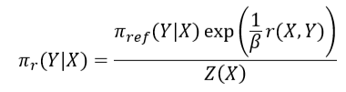
- Subtracting the reward model for two samples eliminates the need for the partition function
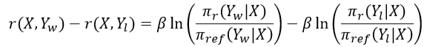
- Loss function:
